Lab Manual# 7

Objectives:
- To learn and understand how to design a multiple output combinational circuit using XOR and XNOR
- To learn and understand the working of different types of decoders
- To learn and understand how to design a multiple output combinational circuit using Decoders

Exclusive-OR & Exclusive-NOR gates:
The figure given below shows the symbol of Exclusive-OR (XOR) and Exclusive-NOR (XNOR) gates.
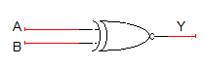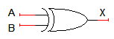
XNOR gate XOR gate
Boolean expression of XNOR gate is$AB+ \overline{A}\overline{B}$ and Boolean expression of XOR is$\overline{A}B+A\overline{B}$. Boolean expression of XNOR gate can be implemented using XOR gate as shown in figure below:

Function Table:
Inputs |  | Output
A | B | Y
L | L | L
L | H | H
H | L | H
H | H | L
H= Logic High, L= Logic Low

Connection Diagram:
74LS86 IC will be used for implementation of XOR gate function. 74LS86 IC contains four 2-input XOR gates. The function table and connection diagram for this IC are shown below:
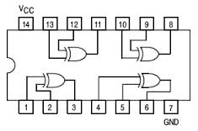
2-to-4 line decoders:
74LS139 IC contains two fully independent 2-to-4 line decoders with active low enables. The function table and connection diagram for this IC are shown below:
Function Table:
Enable | Selection Inputs |  | Outputs
G | B | A | Y0 | Y1 | Y2 | Y3
H | X | X | H | H | H | H
L | L | L | L | H | H | H
L | L | H | H | L | H | H
L | H | L | H | H | L | H
L | H | H | H | H | H | L

H= Logic High, L= Logic Low, X= Don’t Care
Connection Diagram:

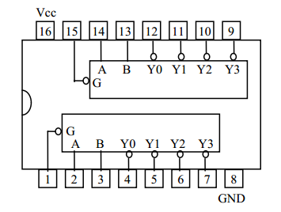
3-to-8 line decoders:
74LS138 IC contains 3-to-8 line decoder. The function table and connection diagram for this IC are shown below:
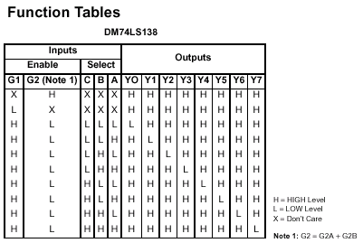
Connection Diagram:

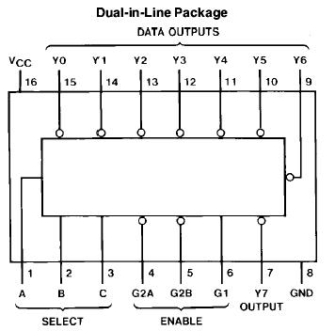

Lab Tasks:
Question 1:
2-bit parity Checker
Implement a circuit that receives 2-bit message and outputs Error (E=0) if its parity is ODD
(Implement it using XOR and XNOR gates)

Question 2:
Make a truth table and implement 2x4 Decoder with a low enable using 8 AND gates and 3 NOT gates.

Question 3:
Implement 3x8 decoder using two 2x4 decoders and NOT gate

Question 4:
Implement a doubler circuit. It takes a 3-bit input and multiplies it by three and gives a 5-bit output.
(Implement it using XOR and XNOR gates)

